PSYC 350 Project 3 Report:

Personality, Sexual Attitudes, and Fluctuating Asymmetry

Taylor Sabatini

University of Illinois Urbana-Champaign

Abstract

In recent years, evolutionary psychology has studied the relationship between physical symmetry of the body and attitudes on sexuality and sexual behavior. Body and facial symmetry, or lack thereof, can predict these attitudes and behaviors in human beings, and we hypothesized that those with more symmetrical faces would have more unrestricted sexual attitudes and be more open to new experiences. Our lab group administered a survey to sixteen college students that asked them to rate on a scale their unrestricted sexual attitudes and their openness to new experiences over multiple questions. We then collected headshot images of each of the sixteen participants that were used to facial symmetry score analysis done through a website. After relating facial symmetry scores to survey results, we found no significant correlation between any of the three variables, suggesting little connection between openness, unrestricted sexual attitudes, and facial symmetry or asymmetry.

Introduction

In this study, we were interested in studying the relationship between openness, sexual attitudes, and facial symmetry. We hypothesized that the three variables would have positive relationships with one another, so our main research question asked this: how do these three variables affect one another and correlate with each other considering that one is physical, one is behavioral, and one is related to personality?

Evolutionary psychologists have been studying this topic area more in recent years. Studies on symmetry and its relation to attractiveness, sexuality, behavior, and perception of others have been conducted and usually offer some insight into its level of predictability. A study conducted between psychologists at Texas A&M and University of New Mexico, entitled ‘Fluctuating asymmetry, sociosexuality, and intrasexual competitive tactics,’ studied the behaviors of various homosexuals that were competing with other homosexuals for a date and how it related to their physical symmetry. While no effects were found on women, homosexual men with greater symmetry and a more unrestricted sociosexual orientation were more directly competitive compared to asymmetrical, restricted men. These men who were low on symmetry and more restricted tended to focus on appearing kind and having positive personal qualities. Another study by Grammer and Thornhill, entitled ‘Human (homo sapiens) facial attractiveness and sexual selection: The role of symmetry and averageness,’ predicted that both men and women would prefer averageness and symmetry in faces of people of the opposite sex as it pertains to attractiveness. Although the hypothesis about averageness was not supported, it was proven that both sexes do in fact find people of the opposite sex with more symmetrical faces to be more attractive.

Making use of this knowledge, our study hopes to further the research on symmetry’s ability to predict sexual attitudes but also specific personality traits. Our research aims to reaffirm the idea that symmetrical faces correlate positively with more unrestricted and dominant sexual attitudes, and we also wanted to expand upon this topic by taking into account a third variable. Measuring openness as a personality trait fits along with the characteristics that define unrestricted sexual attitudes, and therefore should expand positively on this subject area.

Our specific research project, while measuring symmetry of the face as well as sexual attitudes, intends to take into account a third personality variable: openness to new experiences. In order to do so, we conducted a study that contained a brief survey to measure the attitudes and personalities of each individual as well as collected photos for symmetry analysis.

Method

Our group started by coding a survey we could administer to participants using HTML. We made use of two scales: one containing ten questions relating to unrestricted sexual attitudes and one containing ten questions relating to openness to new experiences. After coding all twenty of these questions into one multiple-choice survey, we sent out a link with the survey to sixteen people for them to complete. Of these sixteen individuals, eight of them were women, eight of them were men, all were undergraduate students ranging between eighteen and twenty-two years old, the majority of them were White. We then proceeded to collect headshots of each individual in “mug shot style” so we could upload them to a site called ‘Anaface - Facial Beauty Analysis’ for symmetry analysis and scoring. The site gave each face a score out of ten, and this score was added to each person’s individual dataset. After collecting the data for all sixteen people, we uploaded this data en masse to SPSS for further analysis. After calculating everyone’s average score for unrestricted sexual attitudes and openness to new experiences, we used SPSS to find correlations, partial correlations, and regressions between the three variables studied.

Results

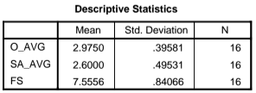 Figure 1

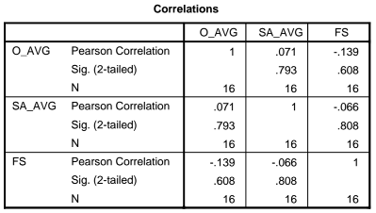 Figure 2

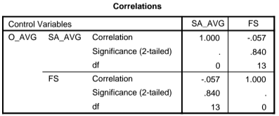 Figure 3

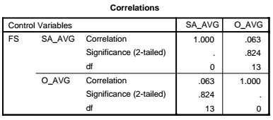 Figure 4

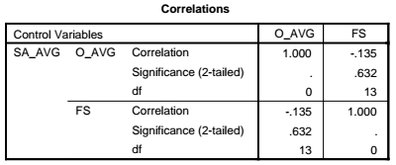 Figure 5

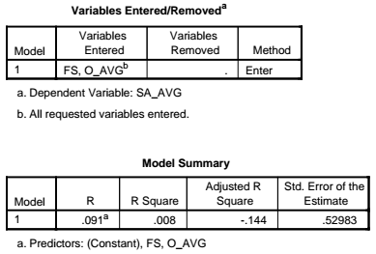 Figure 6

After finishing data collection, our group used SPSS to analyze the relationship between the three variables in a variety of ways. In Figure 1, we calculated the average score for openness, sexual attitudes, and facial symmetry and found that our participants were, on average, fairly open, unrestricted about their sexual attitudes, and had relatively high facial symmetry. We then decided to examine the correlations between each of the three variables, and unfortunately, we found nothing of great significance. Our strongest relationship was between openness and facial symmetry with a correlation coefficient of -.139, which suggests that there is a slightly inverse relationship between the two. We went on to perform partial correlations, controlling for each of the three variables over a series of three calculations, and once again, no significant relationships were discovered besides a slightly negative correlation (-.135) between facial symmetry and openness while controlling for sexual attitudes. Finally, we performed a regression analysis where sexual attitudes served as the dependent variable and the predictors were facial symmetry and openness. Our R square value (.008) proved to be insignificant, and our adjusted R square value (-.144) suggested that we were trying to find too much with too small of a N value.

Discussion

We began this study with the intention of observing the relationship between openness to new experiences, sexual attitudes, and facial symmetry. We hypothesized that high facial symmetry scores would be an indicator of more unrestricted sexual attitudes and greater levels of openness. Through photos and a survey, we hoped to see a positive relationship between each of the three variables.

After analyzing our data, we did not find any relationships of statistical significance. All of our correlation coefficients were very low, and even the strongest of our relationships was shown to be very weak and negative, which is not what we expected. Our analysis also suggested that we had too small of a sample pool to find any significant information on the relationships we were studying. Unfortunately, in the end, our data showed little to no correlation between any of our variables.

Since our data proved to be widely inconclusive, it can be assumed that more thorough and large-scale studies need to be conducted on this research topic for further investigation. Our sample pool was very small and drew no real conclusions on the subject, so in future studies on this topic and others in evolutionary psychology, more participants would be necessary for a successful study. If a larger and more detailed study similar to this one were to be conducted with similar results, we would be forced to ask the question: is there truly any existing relationship between these variables?

There were several limitations to our research methods. The one major issue that has been discussed throughout this report is our small number of subjects in the study. At only sixteen participants, our N was much too small to provide any conclusive evidence on the variables studied. Another aspect of our study that was problematic was the website we used to measure facial symmetry, Anaface. We searched through a multitude of apps and websites in order to find a reliable one, but most of them seemed gimmicky and favoring of certain facial features such as smiles. While Anaface seemed to be the most accurate out of all of them, it still had some obvious faults and incompatibilities with some of our photos. A more legitimate and professional facial symmetry measuring tool would have been helpful in providing more accurate scores.

For those wishing to conduct future research on this subject, I would suggest conducting a study similar to ours but on a larger and more refined scale. Two major steps researchers would have to take would be to get a larger sample size and find or design their own facial symmetry measurement tool that is reliable. Future studies may also wish to focus more on restricted attitude scales, whole body symmetry, or a different personality trait in order to get better results.

References

Grammer, K., & Thornhill, R. (1994). Human (homo sapiens) facial attractiveness and sexual

selection: The role of symmetry and averageness. *Journal of Comparative Psychology,*

*108*(3), 233-242. Retrieved from

http://search.proquest.com.proxy2.library.illinois.edu/docview/614349824?accountid=14

553

Simpson, J. A., Gangestad, S. W., Christensen, P. N., & Leck, K. (1999). Fluctuating asymmetry,

sociosexuality, and intrasexual competitive tactics. *Journal of Personality and Social*

*Psychology, 76*, 159-172.